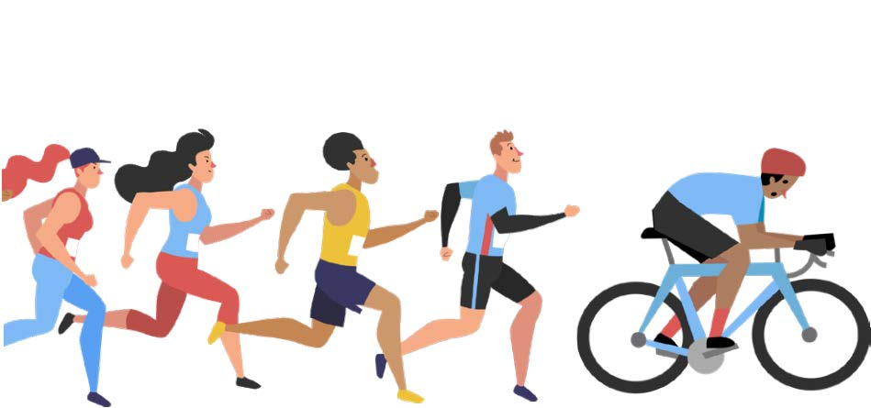

The Mental Health Benefits of Exercise
By Obi McKay

You already know that exercise is good for your body. But did you know it can also boost your mood, improve your sleep, and help you deal with depression, anxiety, stress, and more?

During lockdown, gyms were closed and the ardent gym attenders didn’t know what to do next. We were totally lost and depressed about the prospect of sitting indoors all day. My husband and I went walking anywhere we could without breaking lockdown rules. It was hilarious walking in Epping Forest trying to avoid all human contact. During the hour or two walks we talked, planned trips, discussed the next home improvement and came home feeling totally energised and happy ready for tea.

So, what is mental wellbeing?

Mental wellbeing does not have a single universal definition, but it does encompass factors such as:
- The sense of feeling good about ourselves and being able to function well individually or in relationships
- The ability to deal with the ups and downs of life, such as coping with challenges and making the most of opportunities
- The feeling of connection to our community and surroundings
- Having control and freedom over our lives
- Having a sense of purpose and feeling valued
It is a fact that mental wellbeing does not mean being happy all the time, and it does not mean that you won’t experience negative or painful emotions, such as grief, loss, or failure, which are a part of normal life. However, I’m a great believer that whatever your age, being physically active can help you to lead a mentally healthier life and can improve your wellbeing.

What are the real benefits?

Exercise and depression
Regular exercise can have a profoundly positive impact on depression, anxiety, relieves stress, improves memory, helps you sleep better, and boosts your overall mood. Exercise is a powerful depression fighter for several reasons. Most importantly, it promotes all kinds of changes in the brain, including neural growth, reduced inflammation, and new activity patterns that promote feelings of calm and well-being. It also releases endorphins (our happy chemicals); powerful chemicals in your brain that energize your spirits and make you feel good.

Many of us find it hard enough to motivate ourselves to exercise at the best of times. But when you feel depressed, anxious, stressed or have another mental health problem, it can seem doubly difficult. This is especially true of depression and anxiety, which can leave you feeling trapped in a Catch-22 situation. You know exercise will make you feel better but depression has robbed you of the energy and motivation you need to work out or your social anxiety which means you can’t bear the thought of being seen at an exercise class or running through the park. When you’re under the cloud of anxiety or depression and haven’t exercised for a long time, setting extravagant goals like completing a marathon or working out for an hour every morning will only leave you more despondent if you fall short. Better to set achievable goals and build up from there. So, start small.

People often assume that when they are tired, depressed, or stressed, it seems that working out will just make them feel worse. But the truth is that physical activity is a powerful energiser. Studies show that regular exercise can dramatically reduce fatigue and increase your energy levels. If you are really feeling tired, promise yourself a quick, 5-minute walk. The chances are, once you get moving, you’ll have more energy and be able to walk for longer.

Finally, exercise can also serve as a distraction, allowing you to find some quiet time to break out of the cycle of negative thoughts that feed depression.

Impact on our mood

Physical activity has been shown to have a positive impact on our mood. A study asked people to rate their mood immediately after periods of physical activity (e.g. going for a walk or doing housework) and periods of inactivity (e.g. reading a book or watching television). Researchers found that the participants felt more content, more awake and calmer after being physically active compared to after periods of inactivity. They also found that the effect of physical activity on mood was greatest when mood was initially low.

There are many studies looking at physical activity at different levels of intensity and its impact on people’s mood. Overall, research has found that low-intensity aerobic exercise – for 30–35 minutes, 3–5 days a week, for 10–12 weeks – was best at increasing positive moods (e.g. enthusiasm, alertness).

Higher self-esteem
Exercise not only has a positive impact on our physical health but it can also increase our self-esteem. Self-esteem is how we feel about ourselves and how we perceive our self-worth. It is a key indicator of our mental wellbeing and our ability to cope with life stressors.

Physical activity has been shown to have a positive influence on our self-esteem and self-worth. This relationship has been found in children, adolescents, young adults, adults and older people, and across both males and females.

Regular activity is an investment in your mind, body, and soul. When it becomes habit, it can foster your sense of self-worth and make you feel strong and powerful. You’ll feel better about your appearance and, by meeting even small exercise goals, you’ll feel a sense of achievement. You don’t have to be a fitness fanatic to reap the benefits. Research indicates that modest amounts of exercise can make a real difference. No matter your age or fitness level, you can learn to use exercise as a powerful tool to deal with mental health problems, improve your energy and outlook and get more out of life.

A couple of my friends tackled the introduction to exercise by utilizing the ‘Couch to 5K’ app; a running plan for absolute beginners. Trust me, I witnessed my colleagues walk, struggle with jogging and finally develop the stamina for a straight 10K run and be itching for more.

Feeling bad about yourself
Are you your own worst critic? It’s time to try a new way of thinking about your body. No matter your weight, age or fitness level there are plenty of others in the same boat. Ask a friend to exercise with you. Accomplishing even the smallest fitness goals will help you gain body confidence and improve how you think about yourself.

Better sleep
Even short bursts of exercise in the morning or afternoon can help promote better sleep. If you prefer to exercise at night, relaxing exercises such as yoga or gentle stretching can help promote sleep.

More energy
Increasing your heart rate several times a week will give you more get-up-and-go. Start off with just a few minutes of exercise per day and increase your workout as you feel more energized. Try the ‘Couch to 5K’ it really works.

Even a little bit of activity is better than nothing. If you don’t have time for 15 or 30 minutes of exercise, or if your body tells you to take a break after 5 or 10 minutes, for example, that’s okay, too. Start with 5 or 10-minute sessions and slowly increase your time. The more you exercise, the more energy you’ll have, so eventually you’ll feel ready for a little more. The key is to commit to some moderate physical activity, however little, on most days. As exercising becomes a habit you can slowly add extra minutes or try different types of activities. If you keep at it, the benefits of exercise will begin to pay off. You don’t have to suffer to get results.

Stronger resilience
When faced with mental or emotional challenges in life, exercise can help you build resilience and cope in a healthy way instead of resorting to alcohol, drugs, or other negative behaviors that ultimately only make your symptoms worse. I often go for long walk or run when I’m faced with problems I need to work through. Regular exercise can also help boost your immune system and reduce the impact of stress.

Feeling overwhelmed
When events occur that make us feel threatened or that upset our balance in some way, our body’s defences cut in and create a stress response which may make us feel a variety of uncomfortable physical symptoms, make us behave differently, and experience emotions more intensely.

The most common physical signs of stress include sleeping problems, sweating, and loss of appetite. Symptoms like these are triggered by a rush of stress hormones in our body, otherwise known as the ‘fight or flight’ response. It is these hormones, adrenaline and noradrenaline, which raise our blood pressure, increase our heart rate and increase the rate at which we perspire, preparing our body for an emergency response. They can also reduce blood flow to our skin and can reduce our stomach activity, while cortisol, another stress hormone, releases fat and sugar into the system to boost our energy.

Therefore, physical exercise can be very effective in relieving stress. Research on employed adults has found that highly active individuals tend to have lower stress rates compared to individuals who are less active. However, when you’re stressed or depressed, the thought of adding another obligation to your busy daily schedule can seem overwhelming. You don’t need to devote hours out of your busy day to train at the gym, sweat buckets, or run mile after monotonous mile to reap all the physical and mental health benefits of exercise. Just 30 minutes of moderate exercise five times a week is enough. And even that can be broken down into two 15 minute or even three 10-minute exercise sessions, if that’s easier. If you begin thinking of physical activity as a priority (a necessity for your mental well-being), you’ll soon find ways to fit small amounts of exercise into the busiest schedule.

Dementia and cognitive decline in older people

The same endorphins that make you feel better also help you concentrate and feel mentally sharp for tasks at hand. Exercise also stimulates the growth of new brain cells and helps prevent age related decline.

Improvements in healthcare have led to an increasing life expectancy and a growing population of people over 65 years. Alongside this increase in life expectancy, there has been an increase in the number of people living with dementia and in people with cognitive decline. The main symptom of dementia is memory loss; it is a progressive disease that results in people becoming more impaired over time. Decline in cognitive functions, such as attention and concentration, also occurs in older people, including those who do not develop dementia. Physical activity has been identified as a protective factor in studies that examined risk factors for dementia. For people who have already developed the disease, physical activity can help to delay further decline in functioning. Studies show that there is approximately a 20% to 30% lower risk of depression and dementia for adults participating in daily physical activity. Physical activity also seems to reduce the likelihood of experiencing cognitive decline in people who do not have dementia.

Make exercise a social activity
This is not only physically rewarding but gives you something to look forward to each week. Exercising with a friend or loved one, or even your kids, will not only make exercising more fun and enjoyable, it can also help motivate you to stick to a workout routine. You’ll also feel better than if you were exercising alone. In fact, when you’re suffering from a mood disorder such as depression, the companionship can be just as important as the exercise.

How about our Interpersonal skills
When people are exercising with a friend or partner, they are finding quality time to spend together and keeping each other motivated. In addition, by feeling confident from exercise, people will seek out others with the same interests. Therefore, they will begin to develop and strengthen interpersonal relationships as a basic human need. Belonging to a community has a great deal of impact on mental health and fosters social capital.

We now agree that exercise improves mental health by reducing anxiety, depression, and negative mood and by improving self-esteem and cognitive function. Exercise has also been found to alleviate symptoms such as low self-esteem and social withdrawal. Psychiatrists and mental health nurses often state that exercise is especially important in patients with schizophrenia since these patients are already vulnerable to obesity and also because of the additional risk of weight gain associated with antipsychotic treatment, especially with the atypical antipsychotics.

Finally, we need to change the way we view physical activity in order not to see it as something we ‘have to do’, ‘should do’ or ‘ought to do’ for our health, but as something that we do because we personally value its positive benefits to our wellbeing.

Overcoming barriers

It can be a bit scary making changes to your life, and most people get anxious about trying something new. Some common barriers, such as cost, injury or illness, lack of energy, fear of failure, or even the weather can hinder people from getting started; however, practical and emotional support from friends, family and experts really does help.

Making small changes, from leaving the car at home for short journeys or getting off the bus a stop earlier, to higher-intensity activities like joining in with your children’s football game or jogging with the dog, can help to boost your mood.

For more details about how physical activity can help increase wellbeing and prevent or manage mental health problems go to: www.mentalhealth.org.uk.

Obi McKay

Obi McKay

